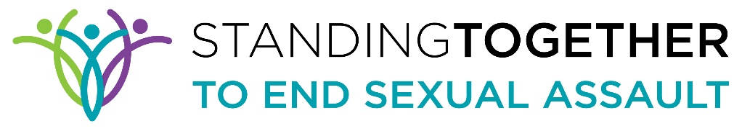
If you suspect someone is being sex trafficked
You must call one of the following:
- Rape Crisis Center Hotline
- Law enforcement
- Call national human trafficking hotline to ask questions, and connect with trained law enforcement.
- For children call CWS: 1800-367-0166
- For Adults call Victim Services: 805-884-8077
For more information:
National Human Trafficking Hotline 1(888) 373-7888
www.traffickingresourcecenter.org
https://polarisproject.org/

